Start Sequenchel

|  |  |
| --- | --- |
|  | Click on Tools / Reports |

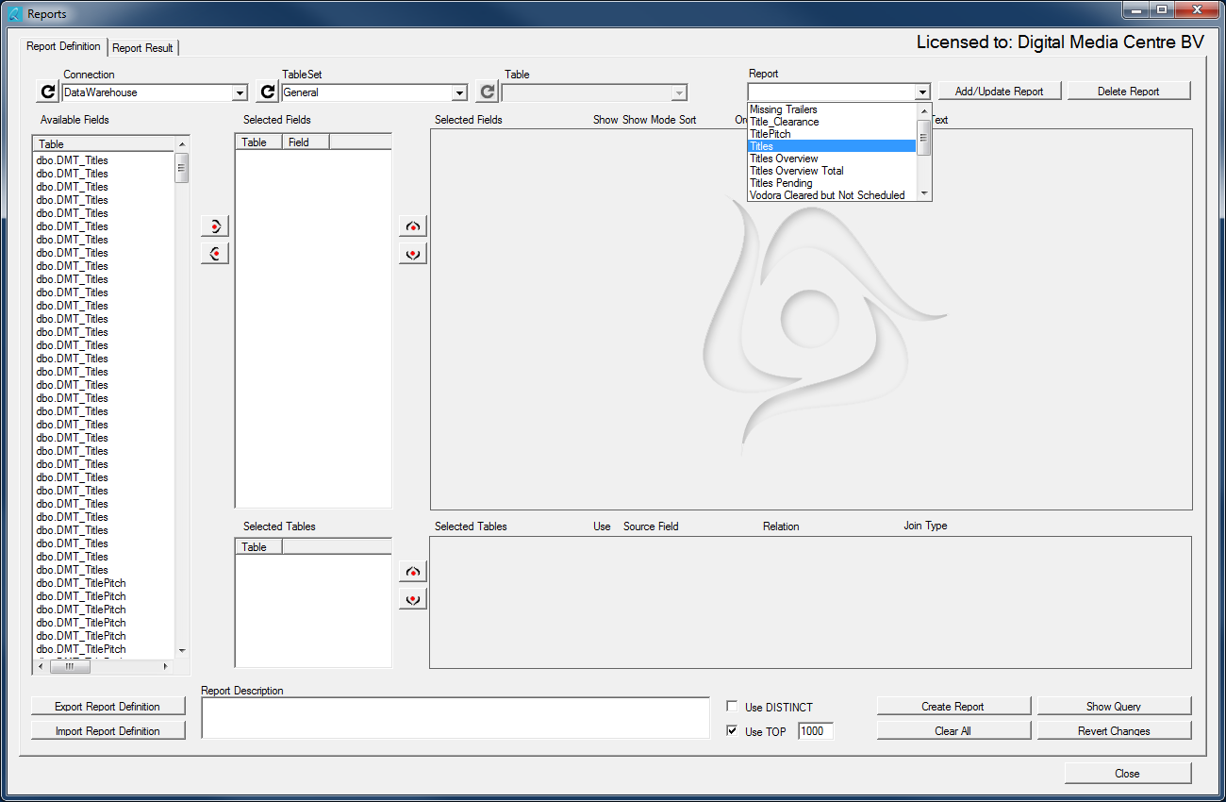

|  |  |
| --- | --- |
|  | Choose the connection where the data is that you wish to report on. |
|  | You can select an existing report from the dropdown list or you can create your own report. If you wish to save your report and you do not have admin rights, you must first select the Table Set “Personal”  “Personal” has the same tables as “General” but it will save everything to your Documents folder.  If there is no “Personal” and you require one, you can request this with your administrator. |
|  | Reports are saved per connection and table set. After selecting the correct connection and table set you can select from the list of existing report definitions.  If the required report does not exist yet, you can create it yourself. |

# Create your own report

|  |  |
| --- | --- |
|  | Select the field you wish to add to your report and click the “Add” button. Do this for every field you wish to add. You can select and add multiple fields at once. |
|  | To remove a field, select the field and click the “Remove” button. You can select and remove multiple fields at once.  To set the fields in the right order, select the field and click the “Up” or “Down” button to move the field up or down. |

Every field in your report has several options.

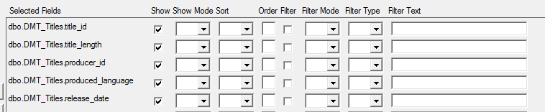

|  |  |
| --- | --- |
|  | Select “Show” if you want this field to be displayed in the report. Leave this unselected if you want to filter on this field without displaying it. |
|  | “Show Mode” can be used to perform an action on the field before displaying it.  SUM: Sum all values of this field and show the total  MIN: Show the lowest value that exist for this field.  Max: Show the highest value for this field.  AVG: Show the average amount for this field.  COUNT: Show the number of rows  These calculations only apply to values where all other displayed fields are identical. |
|  | If the selected field is a Date / Time field you have extra options.  DATE: Show only the date component (leave out time)  YEAR: Show only the year of the date component (e.g. 2016)  MONTH: Show only the month as a number (1 to 12)  DAY: Show only the day as a number (1 to 31)  TIME: Show only the time (leave out date)  HOUR: Show only the hour as a number (0 to 23)  MINUTE: Show only the minutes as a number (0 to 59)  SECOND: Show only the seconds as a number (0 to 59) |
|  | “Sort” determines if the sort order is lowest to highest (ASC / Ascending) (Default) or highest to lowest (DESC / Descending).  This only applies when a sort order is used. |
|  | The “Order” determines if sort is used and in what order. In the screenshot sorting will be done on the second field first, next on the first field and last on the third field. If two fields have the same number, the upper one in the list will be sorted first. |
|  | There are 3 filtering options.   1. No filtering. Leave the checkbox blank. 2. Standard filtering. Check the box 3. Special filtering: Check the box twice to make it grey.   Standard filtering is performed before calculations (Show Mode) are made (WHERE clause). Special filtering is performed after calculations are made (HAVING clause) |
|  | “Filter Mode” determines the relation between your filters.  AND: this filter needs to be applies in addition to the other filters.  AND NOT: Leave out rows that have this value  OR: This filter gives an alternative to the previous filter. “OR” always groups with the previous “AND (NOT)” filter.  OR NOT: The opposite of OR. Groups with the previous AND (NOT).  By sorting the fields in the report you can also determine the order of the filters. |
|  | Filter Type determines how to treat your filter.  = The filter text must be exactly the value of the field  <> value is unequal to the filter text.  < value is smaller than filter text  <= value is smaller or equal to filter text  >= value is larger or equal to filter text  > value is larger than filter text  LIKE: value must contain filter text. Use a % or * sign as a wildcard to tell Sequenchel where in the value you want to search. Text% means the value must start with the filter text. %text means the value must end with the filter text. %text% means the filter text can be anywhere in the value. If you use no % this option is identical to =  NOT LIKE: The filter text must not be present in the value. Use a % sign here as well. |
|  | IS: When looking for empty values you cannot use =. Use IS in combination with NULL to search for empty values.  IS NOT: use in combination with NULL to exclude empty values.  IN: use multiple values in your filter text separated by commas to have your value be equal to one of more options. This is equal to 1 AND and several OR statements.  NOT IN: your value must not be equal to any of the values in the filter text, separated by commas. |
|  | Sequenchel will automatically add quotes if required. The user does not need to add them.  When searching for specific dates, the safest way to enter them is yyyy-mm-dd. |
| Variables v:VariableName(x) | There are several options to search for variable dates. Start each variable with v: to tell Sequenchel you wish to use a variable.  You can add several options between the brackets of date/time variables:  (x), (Year,x), (Month,x), (Week,x), (Day,x), (Hour,x), (Minute,x), (Second,x), (Millisecond,x)  x = the number to add, -x is the number to substract.  These options can be used with every date/time variable. Illegal values or options will be ignored. Every variable has a default option for when only a value is entered. |
| v:Now() | This means the current date and time.  The default value for add/substract is Hour.  v:Now(5) means 5 hours ahead.  v:Now(-3) means 3 hours in the past.  v:Now(Day,2) means current date and time plus 2 days.  v:Now(Year,-3) means current date and time minus 3 years. |
| v:Date() | This means today (date only, no time).  The default value for add/substract is Day. |
| v:Time() | This means the current time (no date).  The default value for add/substract is Minutes. |
| v:MonthStart() | This means the first of the current month (date only).  The default value for add/substract is Month. |
| v:MonthEnd() | This means the last day of the current month.  The default value for add/substract is Month. |
| v:WeekStart() | This means the Monday (first workday) of the current week.  The default value for add/substract is Week. |
| v:WeekEnd() | This means the Sunday (last day) of the current week.  The default value for add/substract is Week. |
| v:YearStart() | This means the first day of the current year.  The default value for add/substract is Year. |
| v:YearEnd() | This means the last day of the current year.  The default value for add/substract is Year. |
| f: | You can also use functions. A function is any valid SQL query, preceded by f:  f:SELECT TOP 1 value FROM tbl_Orders  f: SELECT DATEADD(MONTH,2,DATEADD(DAY,-DAY(getdate())+1,DATEADD(day, DATEDIFF(DAY,0,GetDate()),0)))  [this means 2 months in the future from the first day of the current month; this is the same as v:MonthStart(2) ] |

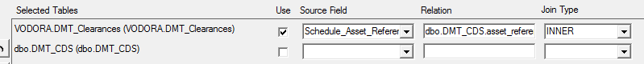

If your report has fields from more than 1 table you need to tell Sequenchel how the tables are related to each other. If relations are known Sequenchel will display those relations but leave it up to you to select the correct one. If the correct relation is defined all you need to do is select the “Use” checkbox. If no relation is defined you must enter it manually.

|  |  |
| --- | --- |
|  | “Source Field” contains a list of all the fields from the corresponding table. Select the field that has a relation to the other table you wish to use. This is usually an ID field. |
|  | “Relation” is the table name and fieldname the Source Field is related to. Write this down as schema.table.field. You can see schema and table name in the list with selected tables. Use the name between the brackets, the other name could be an alias. |
|  | Select the correct type of relation in the “Join Type”  INNER: The value must exist in both tables. Non matching rows/values are left out.  LEFT OUTER: Use all values from the first (left) table and supplement with values from the second (right) table if they exist.  RIGHT OUTER: Use all values from the second (right) table and supplement with values from the first (left) table if they exist.  FULL OUTER: Use all values from both tables and connect them where possible.  CROSS: combine all values from both tables with each other. This may result in a very large result set. |
|  | Make sure the table where most of your fields come from is listed first. The order determines how the relations are build. |



You can save your report by typing a name and click on “Add/Update Report”. If you type an existing name, the existing report will be overwritten. If you select a different report the screen will be cleared and the selected report will be loaded.

If you click on “Delete Report” the selected report will be deleted. There is no undo function for deleted reports.

|  |  |
| --- | --- |
|  | Add a description for your report in the textbox on the bottom of the screen. |
|  | In the lower left corner there are two buttons.  “Export Report Definition” exports your current report definition to an XML file. Use this when you do not have the rights to save a report definition with “Add/Update Report”. You can then send this definition to your administrator so he can import it for all users.  Use “import Report Definition” to import a previously exported definition. The report is loaded but not saved to the report list. |
|  | You can limit the results from your report further by selecting “Use Distinct”. This will eliminate all duplicates from the result set. Duplicates are rows of values that are identical for ALL values.  “Use TOP [1000]” will limit the result set to 1000 rows. This will prevent you from accidentally retrieve millions of rows which will possibly increase your waiting time to hours. Unselect this if you wish to retrieve all rows. |
|  | “Create Report” will build the query for your report and execute it. Sequenchel will switch to the Result tab where the results will be displayed.  “Show Query” will display the query that will be used for your report on the result tab, but it will not execute.  “Clear All” will remove any selections made and clear the screen for a new report.  “Revert Changes” will reload the latest saved definition of the currently selected report, discarding all changes. |
|  | “Close” will close the report screen without saving anything. All unsaved changes will be lost. |

The Report Result tab has several options. When a report is executed, Sequenchel switches to the result tab and the result is displayed

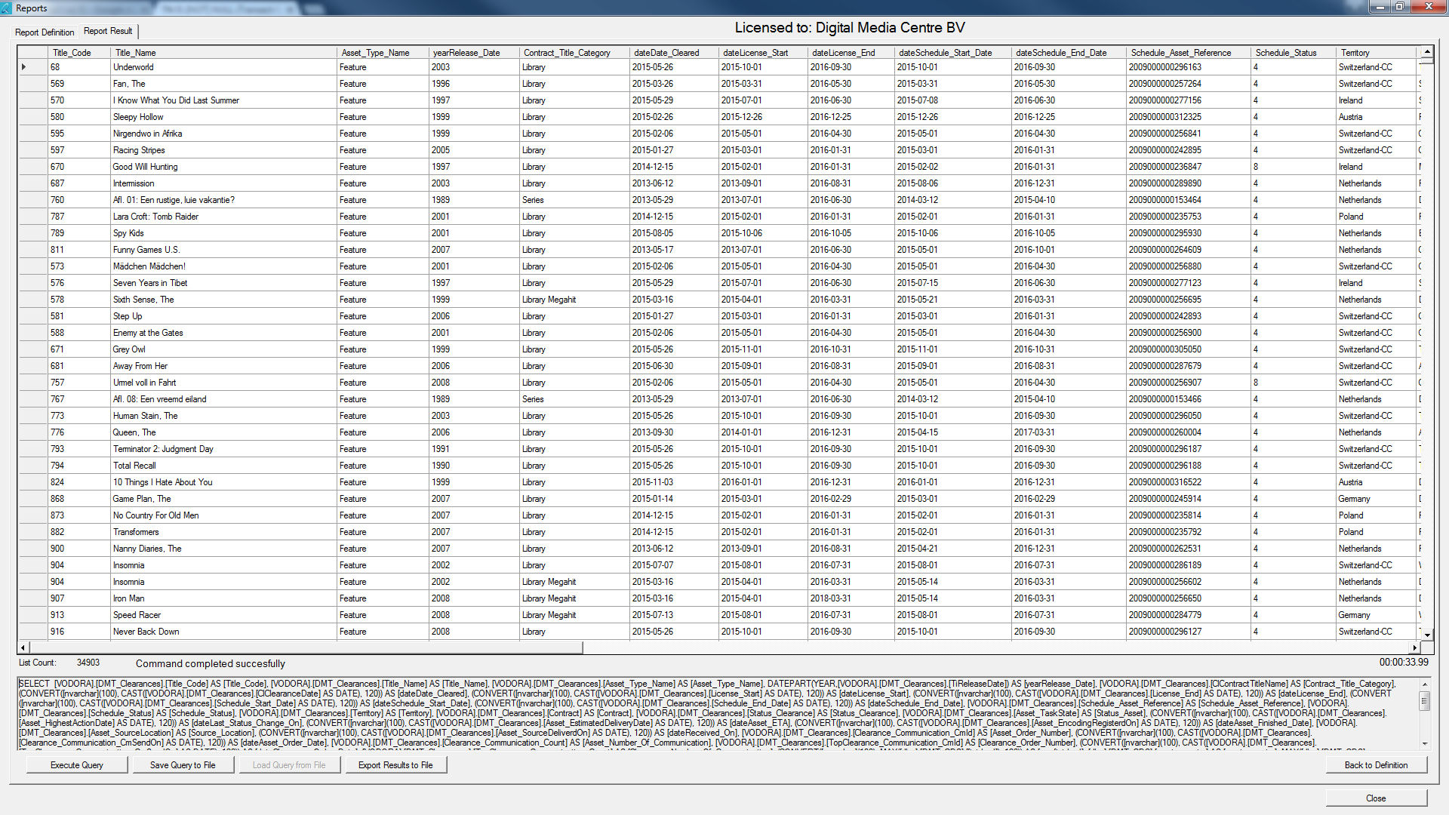

|  |  |
| --- | --- |
|  | The List Count displays how many rows were retrieved for your report.  If no errors occur the status label displays “Command completed successfully”. If an error occurs the error will be displayed here as well as in the log. |
|  | The query display shows the query that was used to build the report. If an error occurs you can copy this query and send it to your administrator for review. |
|  | “Execute Query” will (re)execute the current query shown in the query display.  “Save Query to File” will save the current query to a file.  “Load Query from File” will load an earlier saved query form file and display it in the Query Display.  “Export Results to File” will export the result from the query to a file. |
|  | In the lower right corner the time needed to create the report will be displayed in HH:mm:ss.xx where xx is hundreds of seconds |
|  | Double Click on the upper left corner of the report to resize all columns to fit the data in the report. |
|  |  |

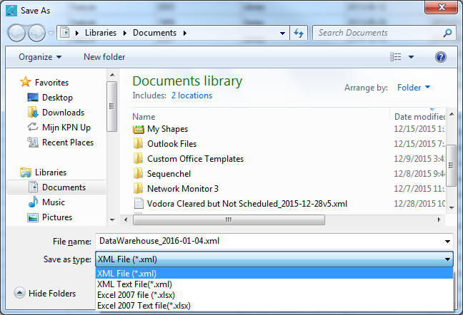

The report will use the name of the report as name of the file and add the current date to it. If no report name is given the name of the first table will be used.

|  |  |
| --- | --- |
| XML File | Standard XML file export. NULL values are ignored so columns may shift |
| XML Text File | Conversion to text only and export to XML. No NULL values exist anymore. |
| Excel 2007 File | Standard export to Excel. NULL values are not handled properly so columns may shift. |
| Excel 2007 Text File | Conversion to text only and export to Excel. No NULL values exist anymore but all datatypes are converted to plain text. |